Lawrenceville mom's home remedy to be offered at Gainesville businesses
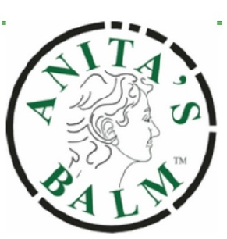

LAWRENCEVILLE — Eczema — the chronic skin condition that can produce scaly, itchy skin and blisters — isn’t much fun for anyone. With kids, it can be an utter nightmare.
“We were dealing with bloody sheets and sleepless nights and trouble at school, issues like that for many, many years,” Lawrenceville mother Anita Redd said.
The steroids given to her son, now 14 years old, produced only minimal success, and eventually stopped working altogether. Redd’s need to help her son, in this case, was the mother of invention.
Redd began experimenting with olive oil, which she had read was a great natural skin conditioner. She “solidified” it with beeswax shavings, and melted it in one of her husband’s stick deodorant dispensers. Voila — Anita’s Balm was born.
For years Kevin used his mom’s remedy to great success, and Redd dished it out to anyone she ran into that had problems like rosacea, psoriasis and alopecia.
“It worked on everything that I ever gave it to anybody for,” Redd said.
By late 2011, Redd decided it was time to incorporate and try selling Anita’s Balm, which now comes in several different forms, to the public. At her first conference, she sold more than 50 tubes of the simple, all-natural product by noon the first day.
The products — including the original balm and lip, hair and eye balms — are now available at more than 1,235 natural food stores and pharmacies nationwide and will be available at two locations in Gainesville - Smoothie King and Medical Park Pharmacy.
Redd's products were featured on report on Fox 5 out of Atlanta.
For more details on Anita's Balm, see her website www.anitasbalm.com.

